From Special Circular 6.3.1/ 143 /244.3/ 15.07.2022

A N N O U N C E M E N T

- GENERAL:

We inform you that Hellenic Post sells Plastic sheets that feature welded crystal clear pockets, suitable for ring binders, where philatelists can keep the items of their collection in excellent condition.

- PRODUCTS:

2.1 “Plastic sheets with welded crystal clear pockets for stamps”:

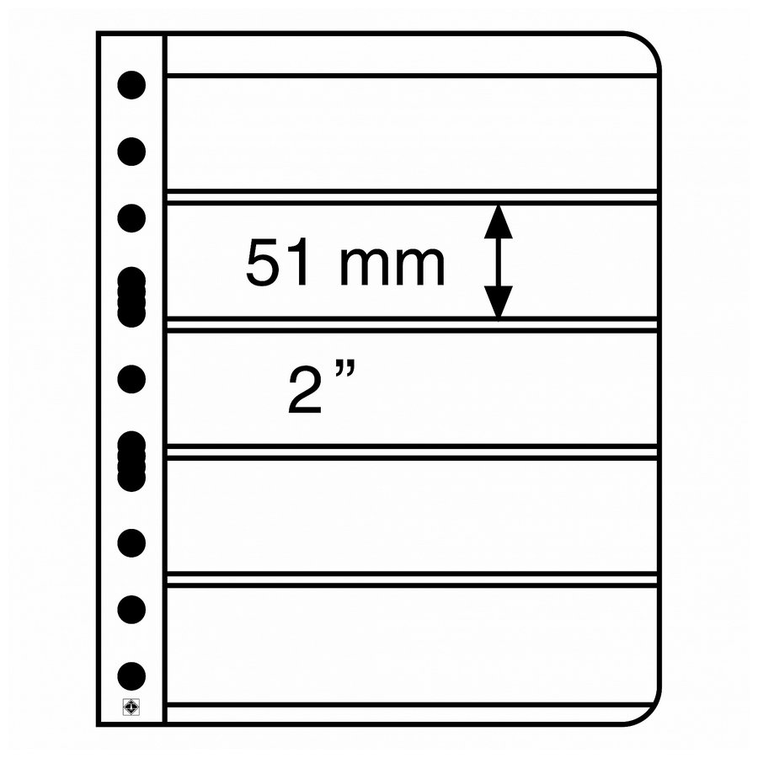 | Color: black
 | Overall size: (W/H) 280 x 216 mm
 | With holes, suitable for all stamps binders
 | 5-way division, Compartment size: (W/H) 195 x 51 mm
 | Manufacturer: LEUCHTTURM, Germany
 | Barcode: 4004117952555
Price: It will be priced at one euro and twenty cents (1,20 €) each, including 24% VAT (0,97 € + 0,23 €). In parts of Greece with a reduced rate of VAT, the price of the sheet will be one euro and thirteen cents (1,13 €) including 17% VAT (0,97 € + 0,16 €).

  - “Plastic sheets with welded crystal clear pockets for blocks of 4 stamps”:

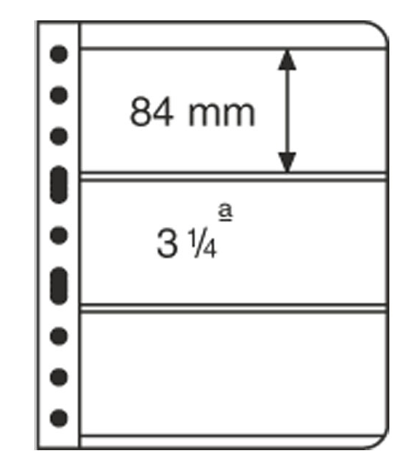 | Color: black
 | Overall size: (W/H) 280 x 216 mm
 | With holes, suitable for all stamps binders
 | 3-way division, Compartment size: (W/H) 195x84mm
 | Manufacturer: LEUCHTTURM, Germany
 | Barcode: 4004117952531

Price: It will be priced at one euro and twenty cents (1,20 €) each, including 24% VAT (0,97 € + 0,23 €). In parts of Greece with a reduced rate of VAT, the price of the sheet will be one euro and thirteen cents (1,13 €) including 17% VAT (0,97 € + 0,16 €).

  - “Plastic sheets with welded crystal clear pockets for stamps sheets”:

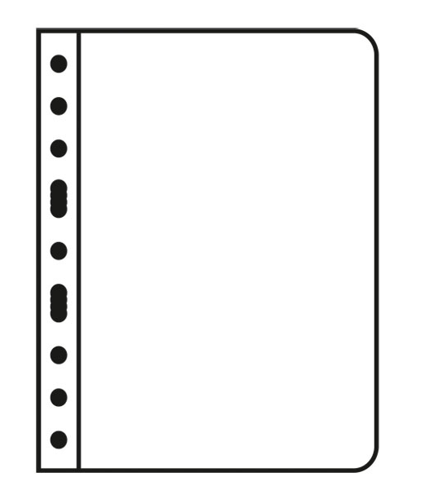 | Color: black
 | Overall size: (W/H) 280 x 216 mm
 | With holes, suitable for all stamps binders
 | 1-way division, Compartment size: (W/H) 195 x 263 mm
 | Manufacturer: LEUCHTTURM, Germany
 | Barcode: 4004117952517

Price: It will be priced at one euro and twenty cents (1,20 €) each, including 24% VAT (0,97 € + 0,23 €). In parts of Greece with a reduced rate of VAT, the price of the sheet will be one euro and thirteen cents (1,13 €) including 17% VAT (0,97 € + 0,16 €).

- AVAILABILITY:

The above product will be available from:

- the Hellenic Post e-shop in the site www.elta.gr
- the post offices in the Hellenic Post network.

List of recipients:
1. All Hellenic Post Departments

FROM THE

PHILATELIC SERVICE

2. List of recipients sent to the Despatch Department
of the Central Service of Hellenic Post

